**Amazon Redshift**

Amazon Redshift is a fully managed data warehouse service in the cloud. Its datasets range from 100s of gigabytes to a petabyte. The initial process to create a data warehouse is to launch a set of compute resources called nodes, which are organized into groups called cluster. After that we can process our queries.

**Redshift Configuration**

Redshift consists of two types of nodes:

🡪Single node

🡪Multi-node

**Single node**: A single node stores up to 160 GB.

**Multi-node**: Multi-node is a node that consists of more than one node. It is of two types:

🡪Leader Node

It manages the client connections and receives queries. A leader node receives the queries from the client applications, parses the queries, and develops the execution plans. It coordinates with the parallel execution of these plans with the compute node and combines the intermediate results of all the nodes, and then return the final result to the client application.

🡪Compute Node

A compute node executes the execution plans, and then intermediate results are sent to the leader node for aggregation before sending back to the client application. It can have up to 128 compute nodes.

**LAB:**

Go to Amazon Redshift service and Click on Create Cluster

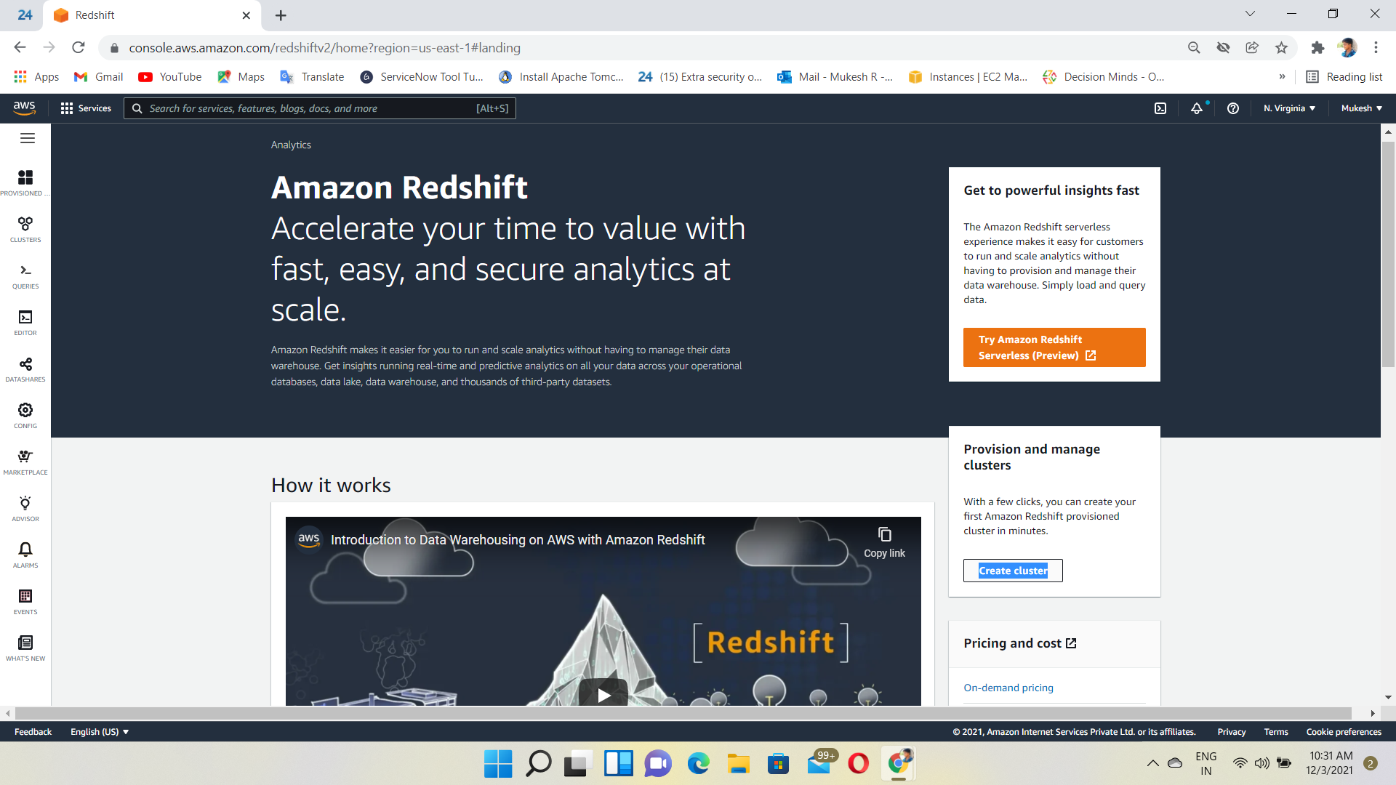

Provide the Required Cluster Details

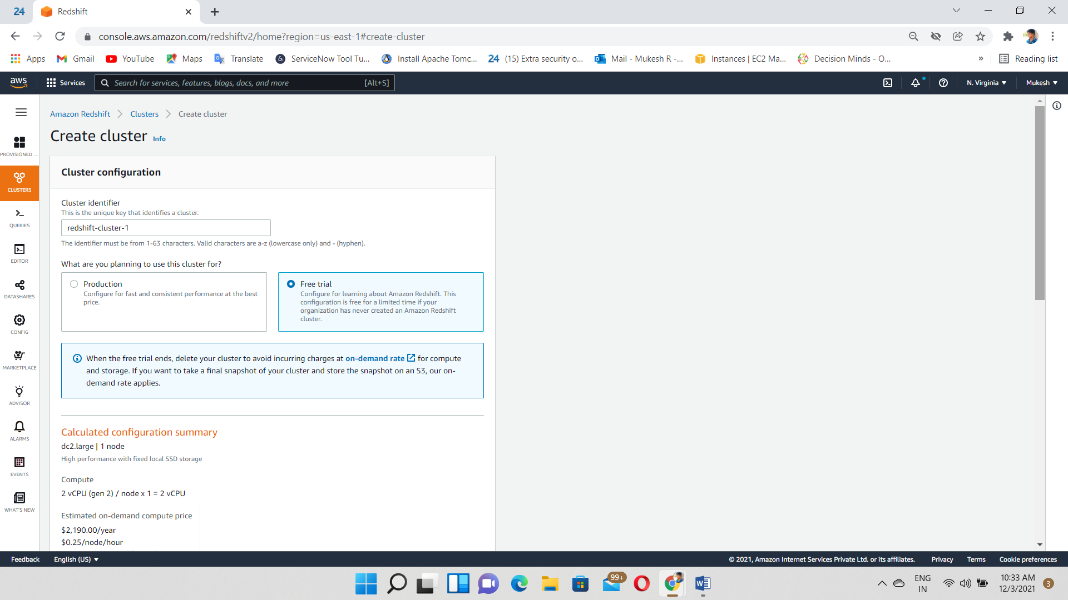

Give a Username & Password we want

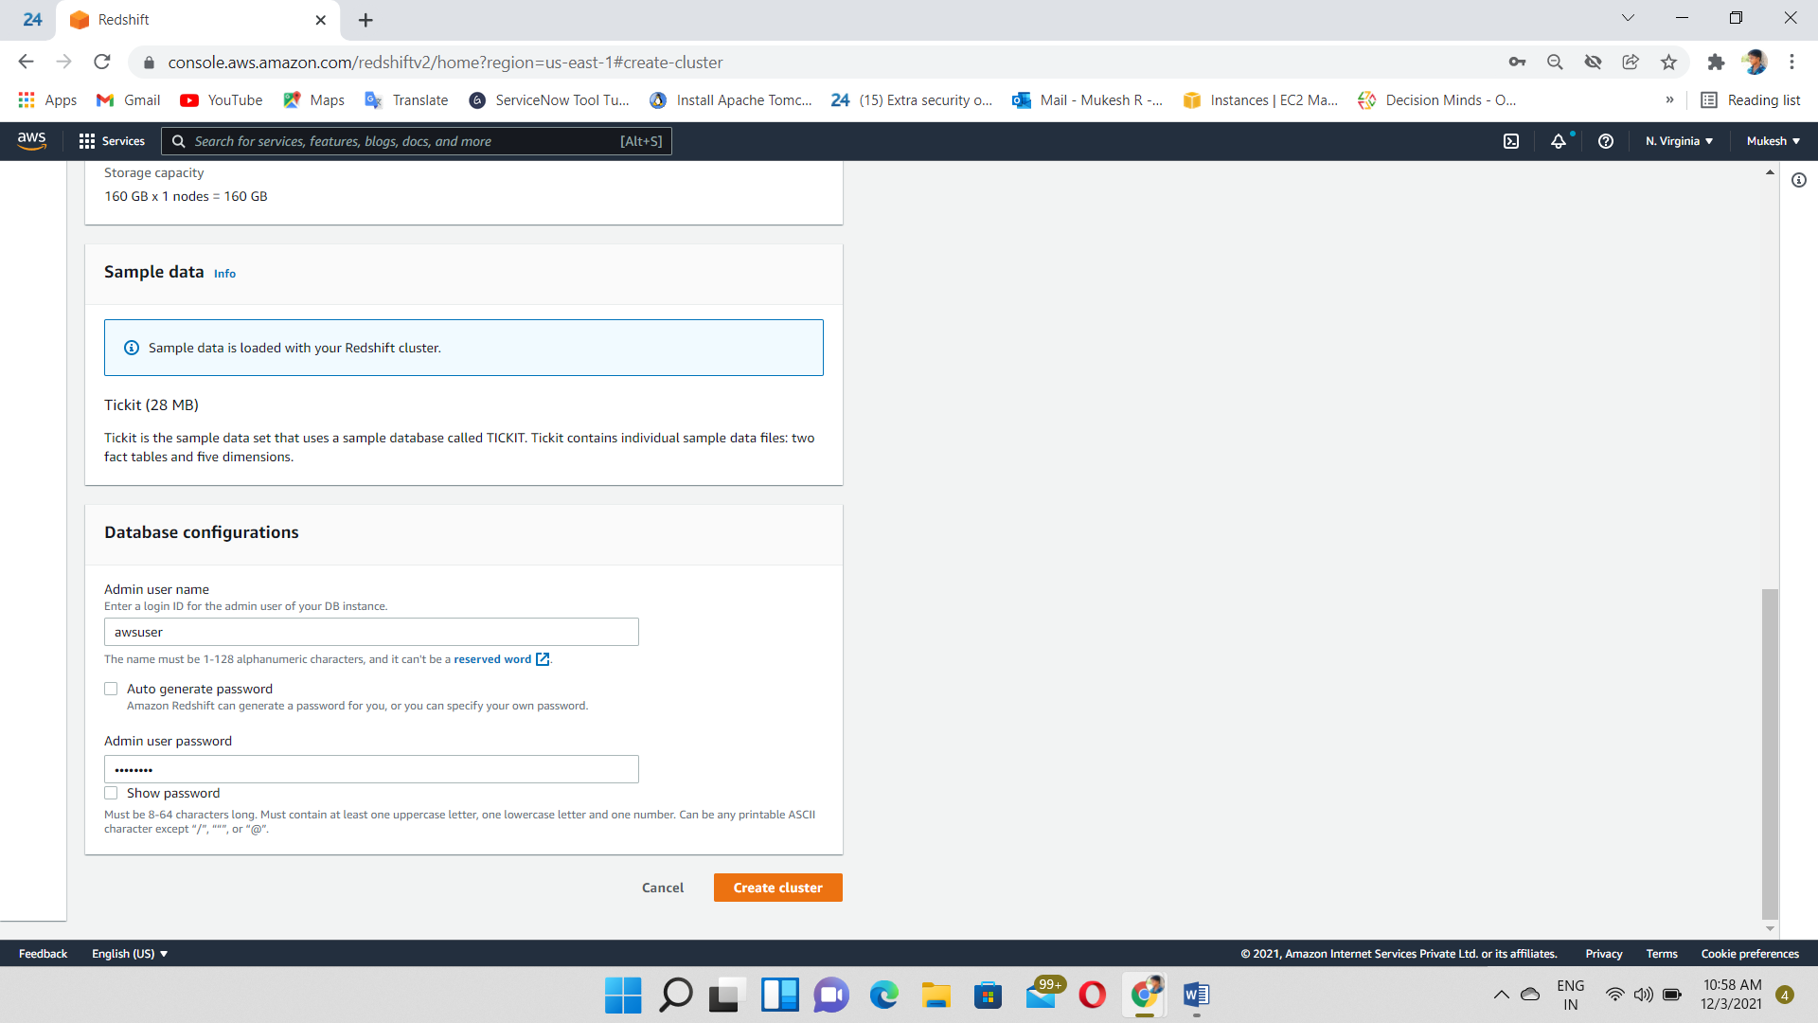

Cluster created and status=available

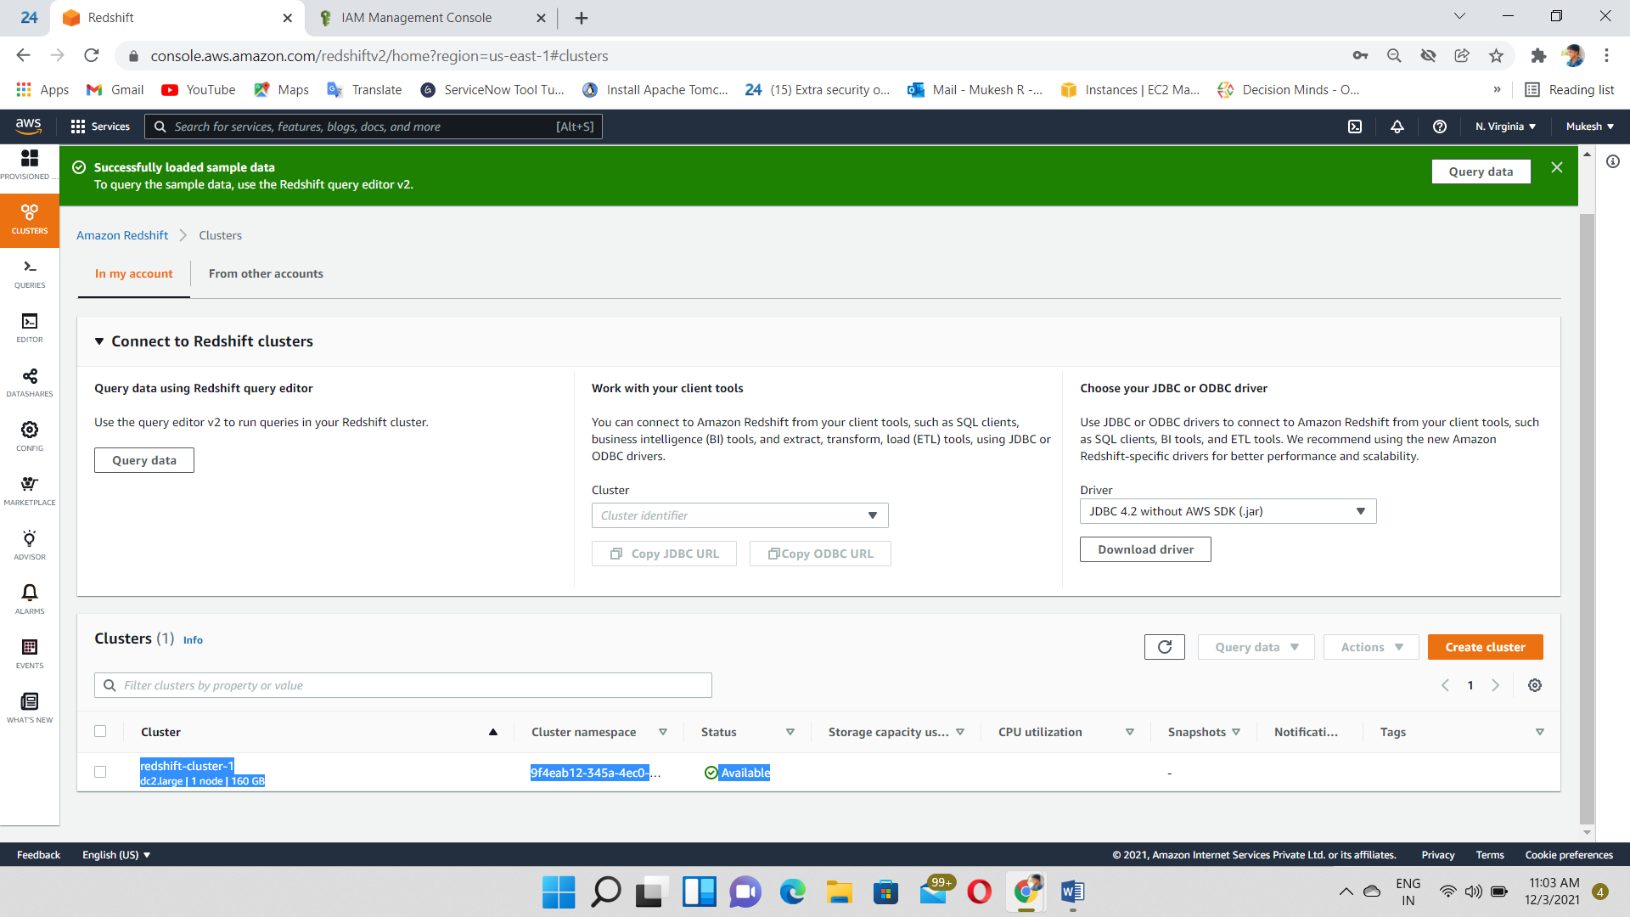

Then, Go to IAM dashboard

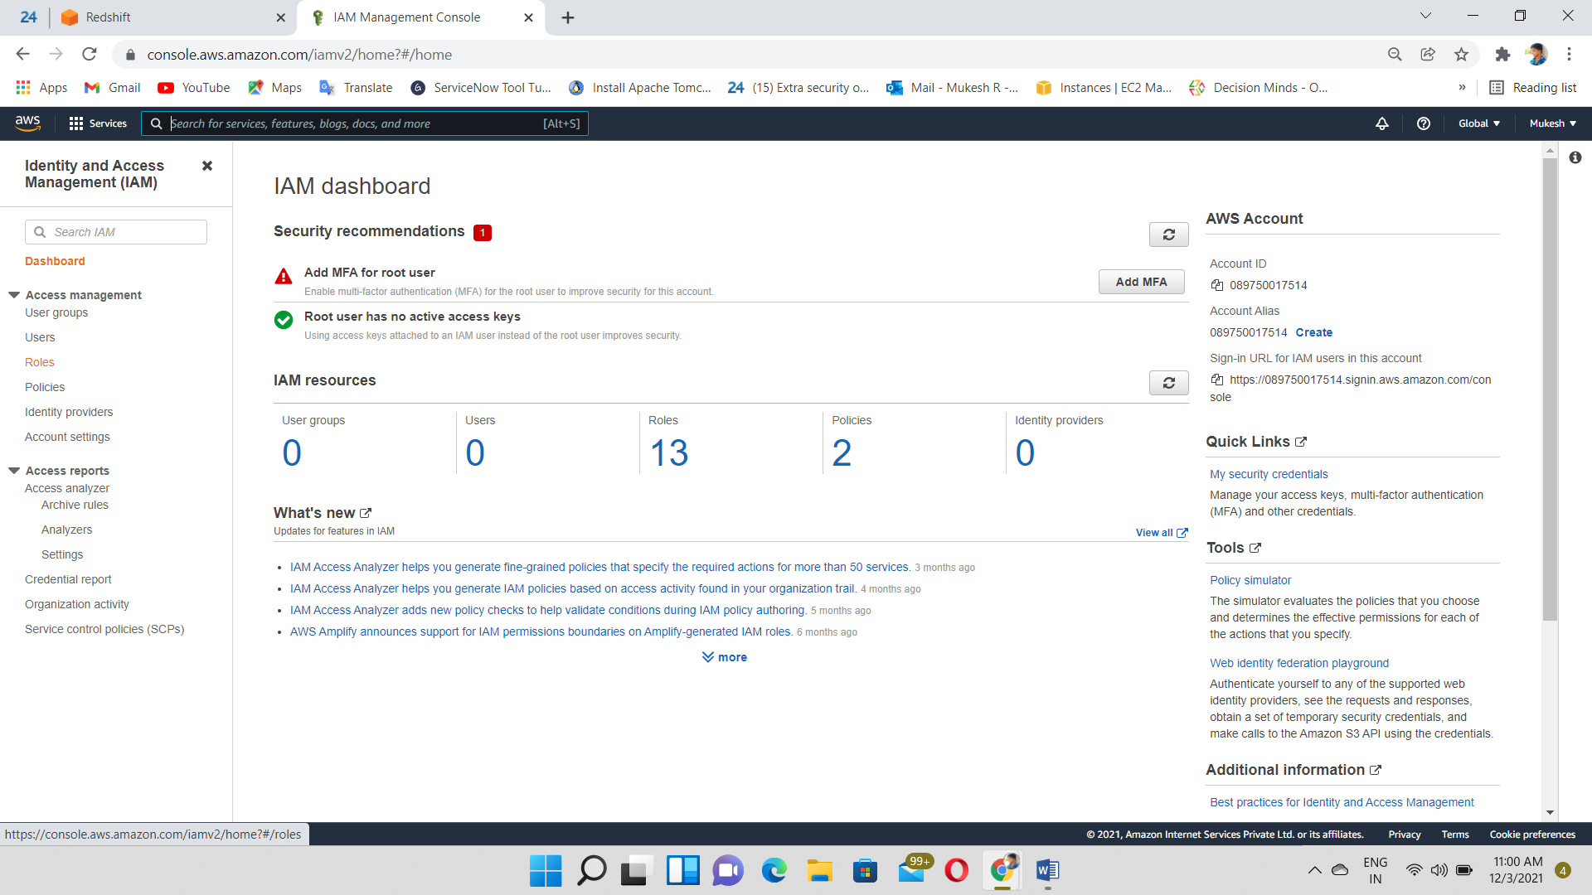

Create an IAM role

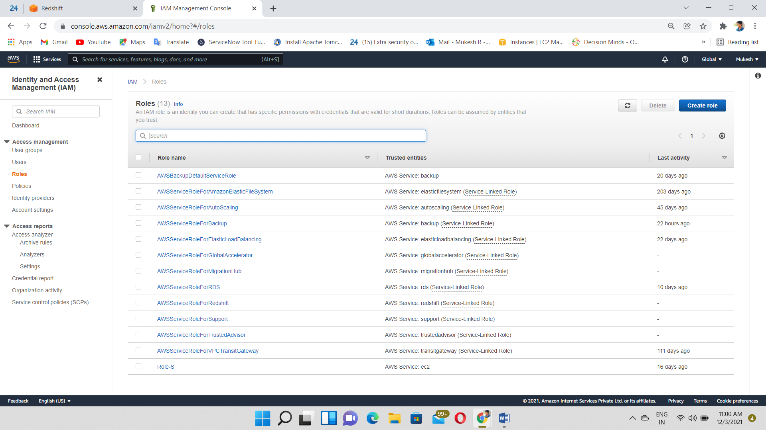

Select Redshift service & use case=Redshift customizable

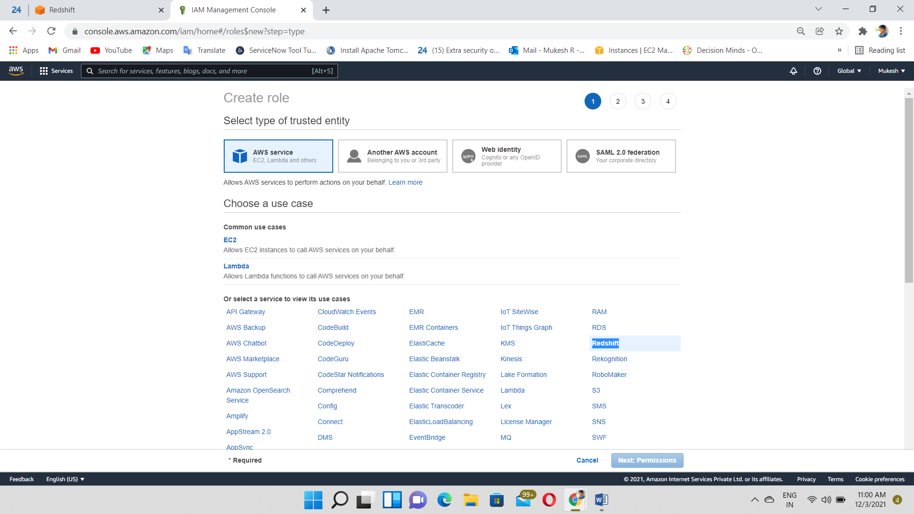

Select s3 read only access permission

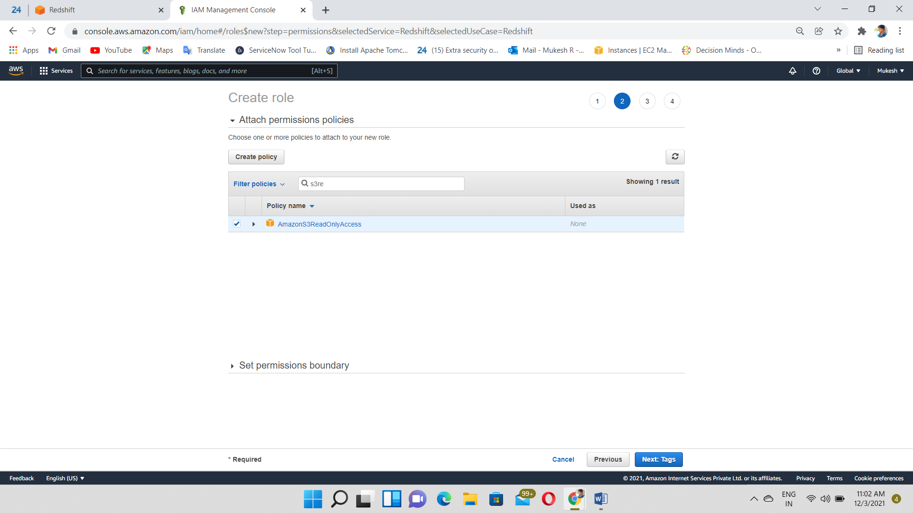

Create a Role

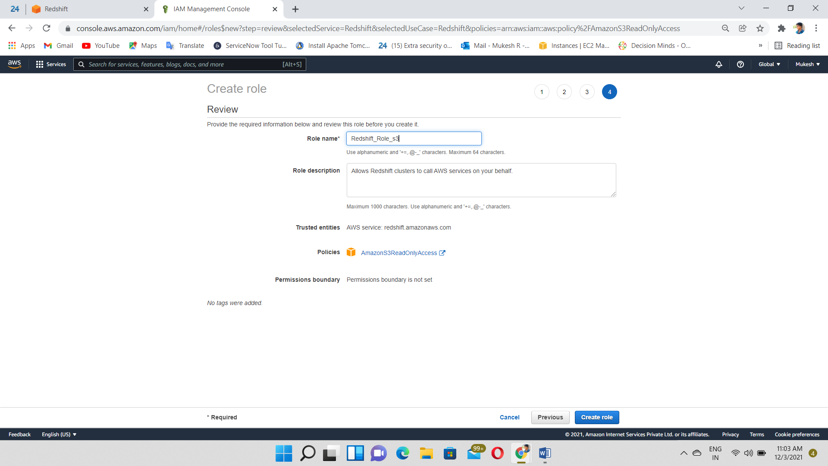

Click on Actions and select Manage IAM role

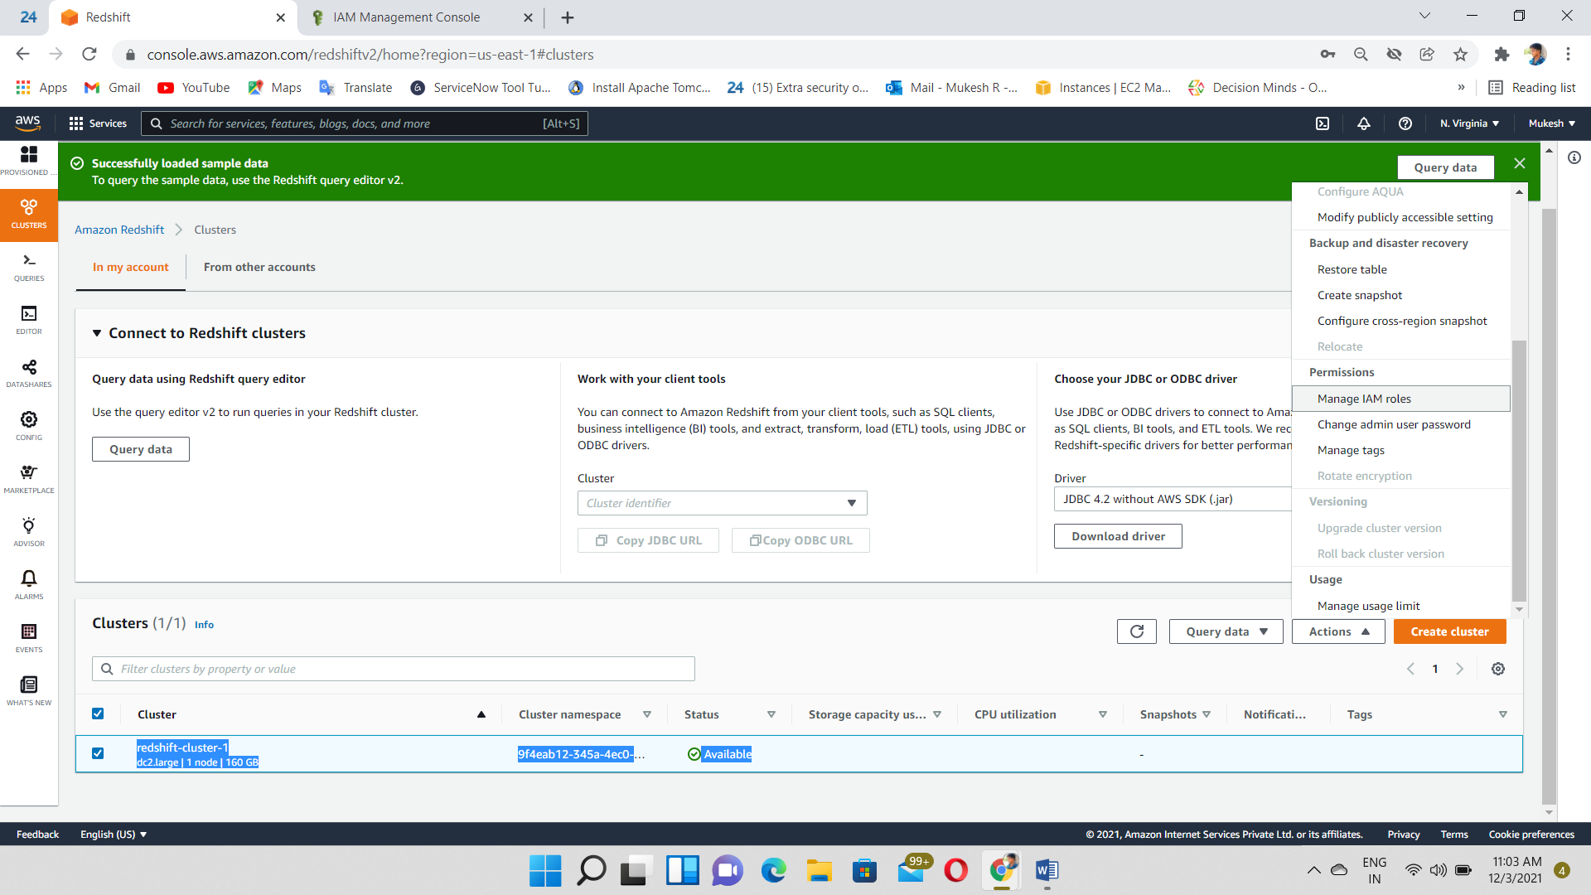

Associate IAM role

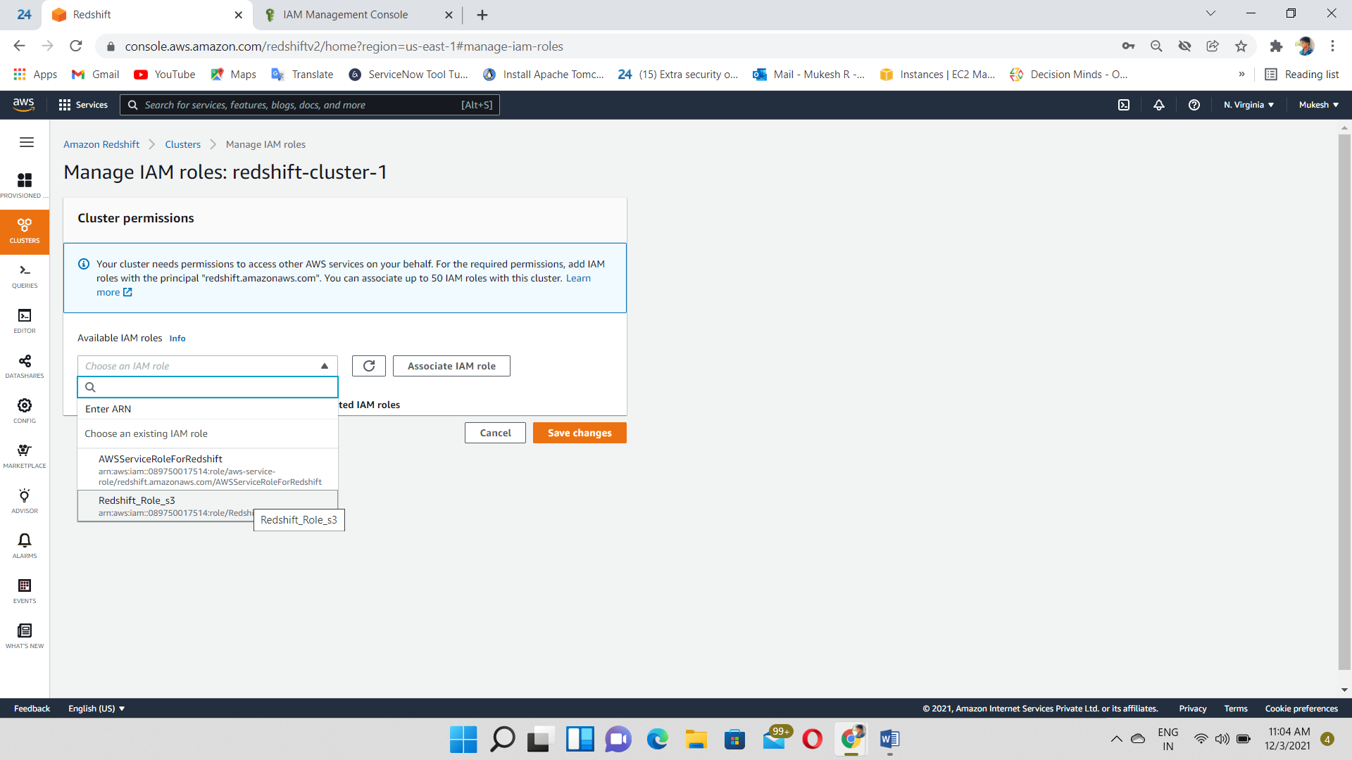

Click on Query editor

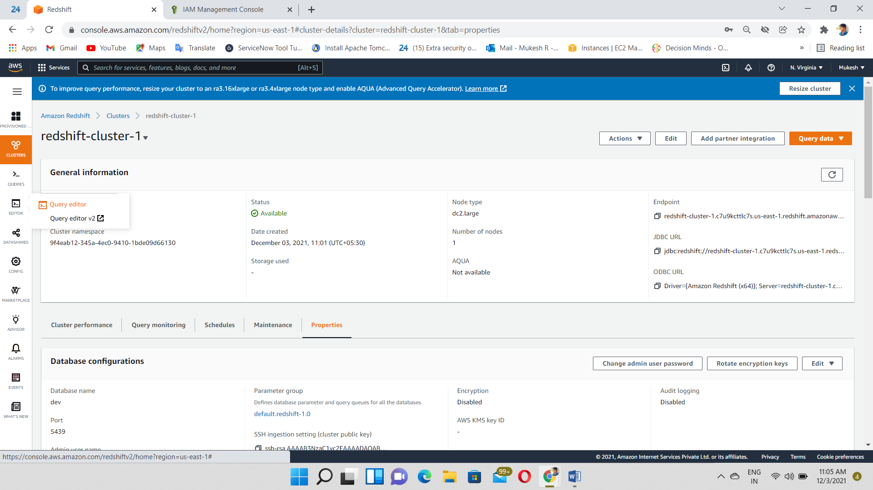

Connect to Database and give the Database details

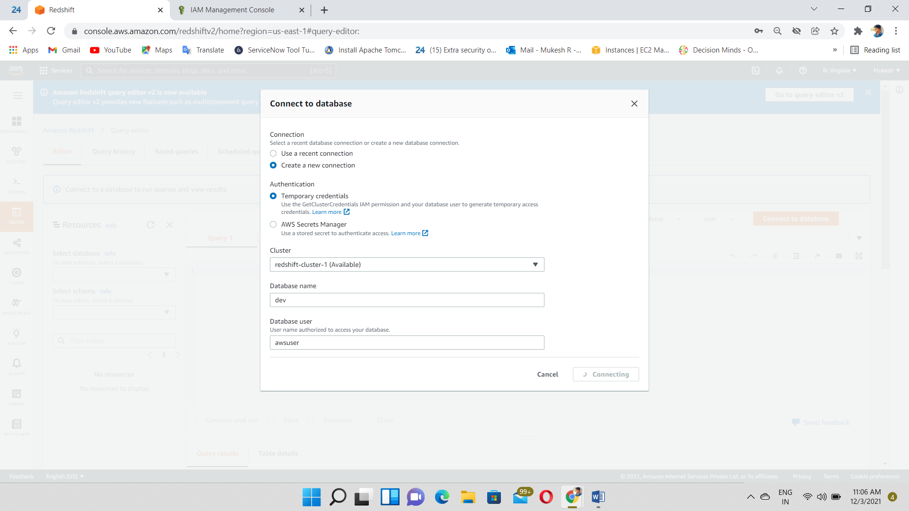

Query editor Connected

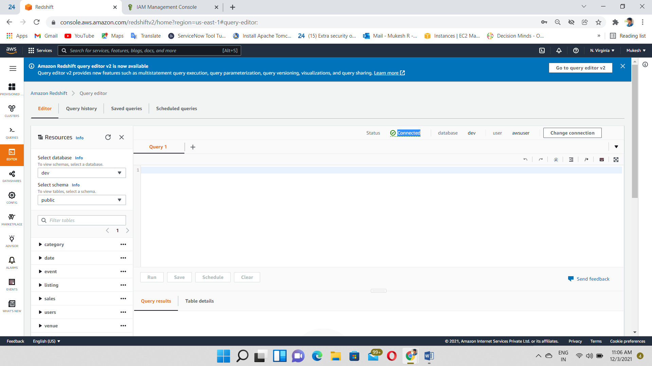

Create Table using SQL command

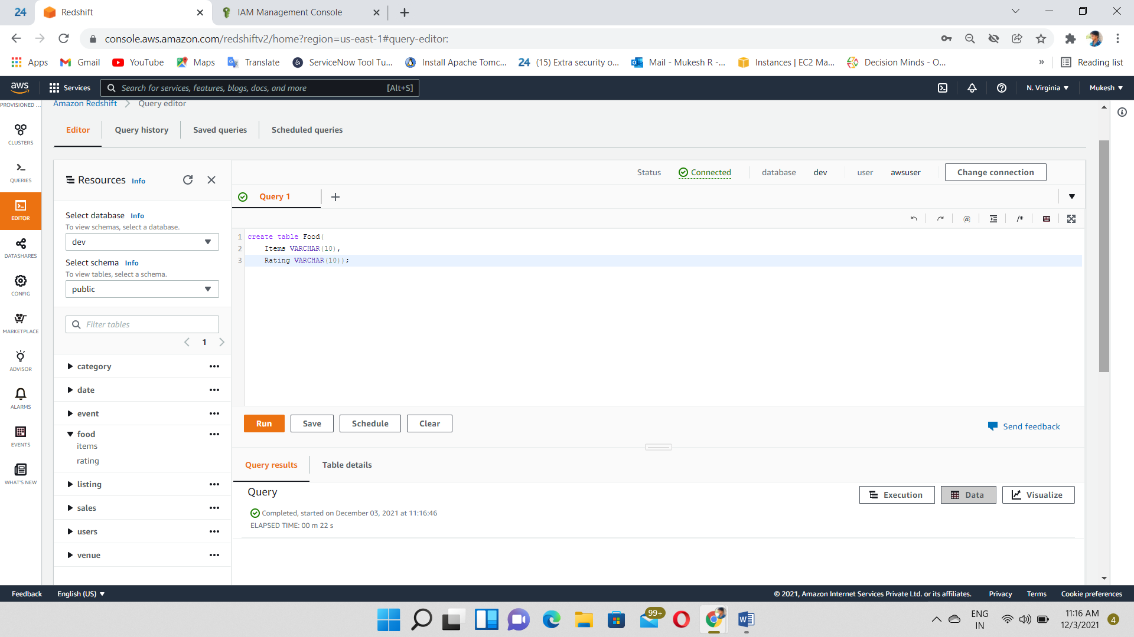

Insert the data using SQL command

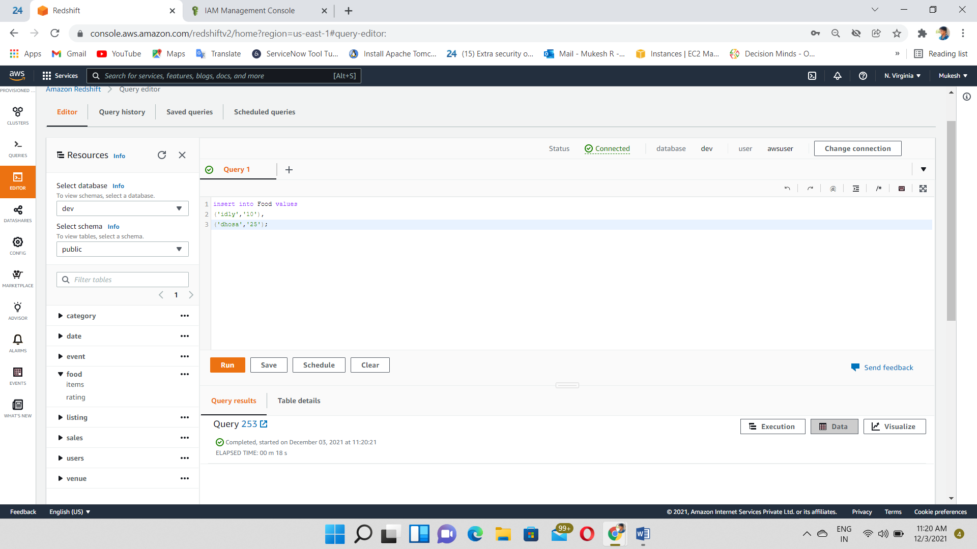

Select data from a Database and then, table displayed

